CST 415 – Final
Steven Reeves
Wilsonville, Fall 2017

This is a take home final. You must turn in your final on Blackboard by mid-night on Monday, 4 December 2017. You may use any and all resources available to you to complete this final. Turn in your own work. Do not copy/paste from a source (for example from the internet), instead read the source, understand the material and then put your answer into your own words.

Section 1 – Terminology and Concepts (50 points)
Answer each question in this section with enough detail that the instructor understands that you understand the term or concept.

- (6 points) Contrast the following terms:
  - LAN address vs. Network address

A LAN (Local Area Network) address is used to identify a particular machine across a “physical” network. This network can be connected by wifi. A network address is used to identify a node across networks. LAN addresses and Network addresses are similar in the fact that they both identify a part of a network. They also share similar in their format, numbers separated by periods.

They are different in the fact that Network addresses are unique, and LAN addresses can be re-used. An example of a LAN address being re-used is the fact that we all used 127.0.0.1 in our assignments for this class. Network addresses must also be issued by an ISP (internet service provider).

A final example of these two addresses is just the setup of a regular household. The network adapter that connects a house to an ISP is issued a Network address (all computers on this network share this address). Within the house itself, each computer has a unique LAN address.

  - Abrupt vs. Graceful Release

Abrupt and graceful releases are similar in the fact that they are both in the Transport layer. They both also deal with how two hosts disconnect with each other.

They’re different in the following ideas. An abrupt release disconnects the connection as soon as the disconnect request is sent. This can result in a loss of data if one side wasn’t finished sending everything. On the other hand, a graceful release will disconnect as soon as both sender and receiver are finished sending everything over. A graceful release would be better for data integrity, while an abrupt release would be better for speed.

  - Hub vs. Switch

They’re similar in the fact that they both send information across a network. They also both take one signal in and have multiple places the signal can go out the other end.

The fundamental difference between the two is that a hub just sends the information down all the ports, while a switch reads the entire packet and sends it to the correct address. One sends information down all the wires, while the other chooses where to send it. The functionality of hubs does end up in collisions, and switches use routing tables to avoid them. Switches are also faster at transmitting data.

- (10 points) Draw the OSI model and place the following protocols in the correct layer: Ethernet, HTTP, UDP, ICMP, ARP, DNS, IP, TCP, SMTP, DHCP

 | OSI Model | Protocols
7 | Application | HTTP, SMTP, DHCP, DNS
6 | Presentation | HTTP, SMTP, DHCP, DNS
5 | Session | HTTP, SMTP, DHCP, DNS
4 | Transport | UDP, TCP
3 | Network | ICMP, ARP, IP,
2 | Data Link | Ethernet
1 | Physical | Ethernet

- (4 points) What characterizes a “routing domain”? Specifically, what do we know is consistent within a domain and how does that help route packets?

A routing domain is a set of routers or networks with a known setup. This routing domain can then be used to find the best way to route packets. This results in a more efficient exchange of information. Administrators use consistent factors such as bandwidth, financial cost, and preference to give a “cost” of communication between each router. Then, when a router needs to communicate with another one, it can determine which the cheapest route is. If a router cannot reach its destination, the cost is set to infinity. Routing domains also help redirect traffic if a router is disconnected from the domain.

- (5 points) Describe the concept of a “sliding window”. What is it used for and why is it used?

A sliding window is a way that a sender can get more than one segment of data over to a receiver without waiting for an acknowledgement (ack) for each segment. This results in much faster transfer of data, as well as the ability to request lost segments.

Basically, there is a sequence of numbers split into 4 categories; acked segments, un-acked segments, available sequence numbers, and forbidden sequence numbers. The window (of un-acked segments) is negotiated between the sender and receiver before transfer begins.

An example of this would be if a sender and receiver agree on a 4 number “wide” window with the sequence of numbers starting at 0. The sender would send its first segment and mark off ‘0’as un-acked. Then it would send 1,2, and 3 and mark of those numbers respectively. Once the sender gets an ack for a segment, it will slide the window over to the next un-acked number. This 4 number window will continue to slide to the right as information is exchanged.

After negotiation, first four numbers are in the window (underlined):
0123456789
After ‘0’ is sent 0 is marked as un-acked (red):
0123456789
After ‘1’ is sent 1 is marked as un-acked:
0123456789
After ‘2’ is sent 2 is marked as un-acked:
0123456789
Sender gets an ack for ‘0’, window is slid to the right, ‘0’ marked as acked (blue):
0123456789

- (4 points) What are the trade-offs between choosing UDP or TCP for implementing your own protocol? Name at least one advantage and disadvantage for each.

UDP is connectionless. This means that data can be delivered in incorrect order and isn’t guaranteed to arrive at all. The main disadvantage here is that some segments can be lost and unordered. An advantage to UDP is that it’s much faster because it doesn’t have to wait for any kind of acknowledgement from the receiver. Additionally, UDP can broadcast segments to many connections at once. If your protocol is okay with losing segments and doesn’t care about the order, then UDP is the best choice.

TCP, on the other hand does require a connection and guarantees in-order delivery. This is also its main advantage over UDP. One disadvantage is that this protocol can be slower than UDP due to the connecting, acknowledgement, and closing times between sender and receiver. Another disadvantage in TCP is the inability to broadcast segments to many connections at once.

- (6 points) Contrast ARP and DHCP. What are they each used for? Describe how they work.

ARP (Address Resolution Protocol) and DHCP (Dynamic Host Configuration Protocol) are similar in the idea that they both connect things with IP addresses. They’re both used to make a connection before sending data over. The main difference in the two is that ARP is at the network level, while DHCP is at the application/presentation/session level. ARP is similar to a teacher calling a student by name and remembering which seat they sit in. DHCP is like a student raising their hand and asking to get a name.

ARP is used to find out which machine on a LAN has a particular IP address. The host first checks to see if the IP address is mapped to a LAN address on the cache. If it is, the host will send the information to the appropriate machine. If not, the host will have to and a broadcast out to the LAN with the destination IP address. Then the correct host will reply directly to the original host. Then the information can be sent and the cache can be updated for future use.

DHCP is used to assign IP addresses to a sub-net. In this case, the client broadcasts a need for an IP, and the server will allocate one. During this broadcast, the client’s LAN address is also sent so the server can contact it with the new IP address. The client then accepts the offer and the connection is made. A lease can also be assigned and the connection is closed after it expires. After a closed connection, the IP address can be reused.

- (5 points) In the following diagram, what would the routing table look like on host A after the following sequence of reports:

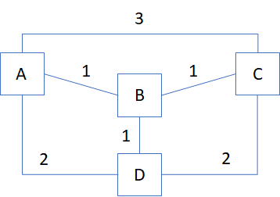
A reports to B, C and D
B reports to A, C and D
C reports to A, B and D
D reports to A, B and C

A’s Routing Table:
Destination | Next Hop | Cost
B | B | 1
C | B | 2
D | D | 2

- (5 points) Describe the distinction between OSI Layer 2 and Layer 3. Why do these two layers exist and are separate? Describe a real-world scenario, using actual protocol names, where the distinction is useful.

Layer 2 (Data Link) is the layer that controls the physical connection between two machines. It’s the protocol that Ethernet uses to send data (in bits and frames). Layer 3 (Network) is the layer that’s responsible for how this data is wrapped up (in packets). The network layer is also where nodes are identified with IP addresses. The two layers are separate so if a change needs to happen at the IP level, the data link layer won’t need to change much. The addition of IPv6 comes to mind.

The situation is analogous to a delivery truck. Layer 1 (Physical) is the road and truck, layer 2 (Data Link) is the driver of the truck, and layer 3 (network) is how the truck is packed with information, and where it’s going. These two layers exist to get data from one node to the correct other node in a network.

A real world scenario would be a switch using ARP (as mentioned in question 6) to send data to a particular machine. The switch first gets the data with an IP address attached and has to broadcast it to all the other machines (assuming the IP address wasn’t mapped to a LAN address already). This is the network layer in action. The data link layer is what drives this information to each node, while the physical layer is medium in which the data moves. Ethernet is the protocol and wire type that combine the physical and data link level. Once a node gets a message with its IP address, it then responds with its LAN address. Then the data can be sent and the cache can be updated for future use.

- (5 points) In socket programming, when would you use ReceiveFrom() vs. Receive()? What must happen prior to using each?

ReceiveFrom() is used to receive data on a UDP socket. Before receiving information a new UDP socket must be created and connected (via Bind()) to an address/port.

Pseudocode for using ReceiveFrom() from the client side:
//
Using statements (System.Net and System.Net.Sockets)

Socket socket = New Socket(SocketType.Dgram, ProtocolType.Udp);
socket.Bind(anEndPoint);
socket.ReceiveFrom( Byte[], someEndPoint);
//

Receive(), on the other hand, is used for a TCP socket connection. This connection would have to be connected to a different socket before being called.

Pseudocode for using Receive() from the client side:
//
Using statements (System.Net and System.Net.Sockets)

Socket socket = New Socket(SocketType.Stream, ProtocolType.Tcp);
socket.Connect(IP address, Port);
socket.Receive ( Byte[]);
//

Section 2 – Understanding Protocols (30 points)
Each question in this section relates to a specific network protocol. Write a couple paragraphs describing the protocol as required in the question. Be complete in your answers and ensure the instructor sees that you understand how the protocol works.

- (10 points) Three PCs are on an Ethernet LAN, connected by a hub. Describe how the Ethernet protocol deals with collisions in this situation. How would the situation change if the hub were replaced by a switch?

A hub is responsible for relaying a signal to multiple computers, in this case the three PCs. The Ethernet protocol deals with both layer 1 (physical layer) and layer 2 (data link). The physical layer in this scenario is the system of wires connecting the hub to the PC’s. The data link layer is all the packets being transferred from each machine. These packets contain a preamble, frame, and gap. The preamble is to allow synchronization between two machines. The frame is what holds the destination address, source address, data, and checksum value. Finally, the gap is left so the hardware can complete any processing.

The initial way that Ethernet deals with collision is to time how long it takes to send a certain amount of bits and get them back. This can be calculated with the speed of light, and the fraction of that speed that cables can send bits. This gives us the length of how far a bit can travel before the next one can be sent. Then we can calculate how many bits can be sent and received in a certain amount of time and add some jam bits to pad the difference. With all this information, a node can know if the entire amount of bits were sent, it can continue to send the next amount of bits.

Along with timing the bits, collision can be found using exponential back off. A transmitting node will first listen before doing anything. If the line is busy, wait for a certain amount of bits. Once that amount has gone by, transmission can begin while watching for collisions. If a collision is detected, the node will cease transmitting, send jam bits, choose a random number of slots to wait (the range for this random number grows each retry), and retry the transmission. If a collision is detected 16 times, the node will stop attempting to transmit.

If the hub were a switch, collision wouldn’t be as much of a problem. A switch reads the entire packet and sends it to the correct address. This would mean we don’t have to worry about two signals going down the same line. The functionality of hubs does end up in collisions, and switches use routing tables to avoid them.

- (10 points) A client program on a PC downloads a large data file from a server using TCP. Describe how the client connects to the server using a 3-way handshake and then downloads the data in order, without loss of data. Use specific TCP terminology in your description.

The first step in getting this data over is to connect. Being that TCP is a connected, guaranteed in-order delivery protocol, this is the correct choice over UDP. The three way handshake happens as follows:

1) Host A sends SYN (synchronize packet) to Host B. B then receives this SYN.
2) B sends back a SYN-ACK (synchronize-acknowledge packet) to A. A receives this SYN-ACK
3) A sends an ACK back to B and the connection is complete.

SYN and ACK are both bits within the header of a TCP segment. These 2 bits can be flipped to make the following messages: (SYN, SYN-ACK, ACK, nothing). The data can then be transmitted using a sliding window (explained in question 4). The window size, segment number and FIN data are all also stored in the header of a TCP segment. The window size is used for the sliding window, segment number is used to keep data in order, and the FIN bit is used to start a close of the connection.

Finally, a graceful close (explained in question 1b) of the connection ensures that all data is transferred before closing the connection. A basic example of the TCP close is below.

1) Host A sends FIN to Host B
2) B replies with ACK
3) B sends rest of data if it has any left
4) B sends FIN when done sending all data
5) A sends ACK for B and the connection is closed

- (10 points) Describe in detail what happens when a user uses a Web browser to access a static HTML file on a Web server using HTTP. The user’s PC and the Web server are on different computers, both on the same Ethernet LAN. Walk through the protocol stack, from HTTP to Ethernet and back, step by step, explaining what happens at each layer.

The first thing that happens is at the application layer when the user enters the URL (Uniform Resource Locator). This standard defines the protocol to use during a request, the host to request from, the path to the resource, parameters to pass to the resource (if applicable), and the fragment of the resource to pull from. An example in this case would be: http://www.someinfo.com/cool/stuff.html .
The second thing that would happen is that HTTP would be recognized as the protocol and used to get the ‘stuff.html’ file from www.someinfo.com/cool . This is also assuming the person entering the URL is using a DNS (domain name system) for the Web server. They could also use the IP address, if they knew it. DNS just makes it easier for humans to remember where to get information. The HTTP protocol itself is implemented over TCP (explained in question 10).
The client (web browser) first sends an HTTP request to the server. This request includes the method (in this case GET), an HTTP header, and an optional MIME (Multipurpose Internet Mail Extension) document. A document won’t be sent because a GET is just a request for a specific resource, in our case the HTML document. The server will then send an HTTP response with a status, HTTP header, and the document requested. If all goes to plan a response status of 200 (ok) will be sent. Once the HTML document is received, the browser will display it in the proper format with all the buttons and links functional. Different controls on the page will have different methods attached to them. For example, a person could enter an email address in a box and click ‘enter’. That enter button would contain a HTTP ‘Post’ method in it to send the address to the appropriate place on the server. There are also a lot of browser/server specific functionalities that could be used. Examples of this would be opening an HTTP session (and issuing keep alives), authenticating the connection (for security), or using HTTP 1.1 methods.
Zooming out, HTTP uses TCP as the transport layer, which uses IP as the network layer, which is driven by the data link/physical layer (Ethernet). Above responses to questions go into more detail about those layers. HTTP will use all of them to send request, receive, and send data to and from the server.

Section 3 – Applying Network Concepts (20 points)
Use what you have learned in this course to design a solution to the following problem, from a networking and network programming perspective. Be as descriptive and specific as possible. Name protocols. Include diagrams as appropriate. Feel free to attach more pages if you are inspired. A single diagram and a page of text are probably sufficient.

Warning: Do not name an existing application that meets the need… design your own!

You are creating an application for OIT students to collaborate on group projects. Students will be able to use lab PCs, laptops and mobile phones. Students in a group may be at any of OIT’s campuses or even at home when working together. Students may join a group at any time, and whenever they are “on-line”, the other students already on-line in the group should be notified within a few seconds. Students may chat, share files and use a shared whiteboard.

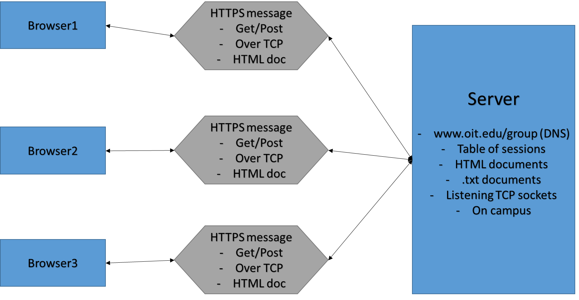
Figure 1: Basic Overview

The basic overview of this application has browsers use the DNS www.oit.edu/group to connect to the server via IP address that’s on campus. The server shown on the right of Figure 1 shows what it would contain. A table of sessions would be mapped to each user and the HTML document would contain text information, the drawing information, and a list of online friends (Figure 2). The server would also have a certain amount of TCP listening sockets.

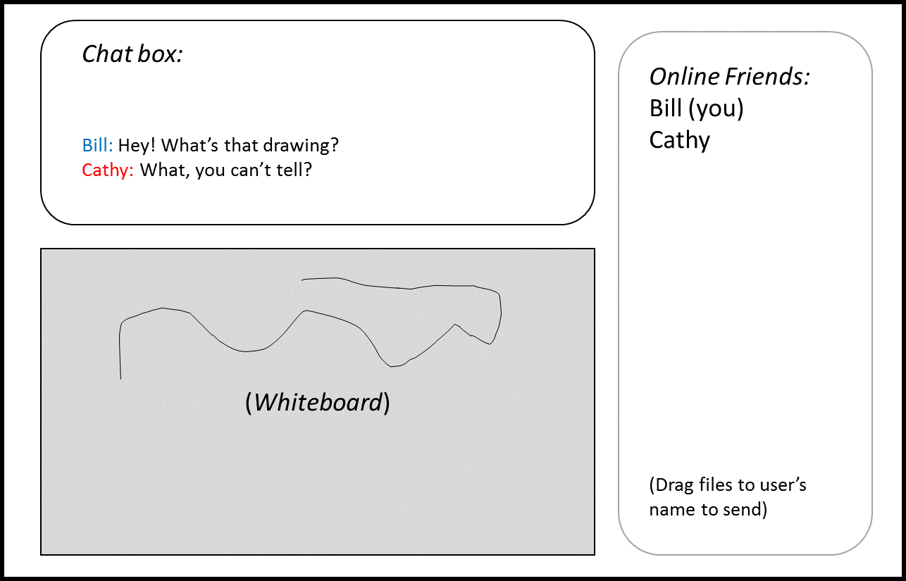
Figure 2: Browser view

Signing on:
A user first signing on would enter the URL and a connection would be made via HTTPS. After a TCP three way handshake, the main page would be loaded. This page would allow the user to enter the username/password. A Post HTTPS message would be sent over the TCP connection to allow the server to open a new session/ resume an old one for the user. The session table would have to have a timeout period as to not waste server space if the user hasn’t been logged on in a while. Once the session is resumed/opened, the HTML document for that session would be sent back to the browser for viewing.

Joining a group:
After signing on, the server would just add the user to a current session. That way when information is updated (i.e. adding text, or drawing) they’ll see the same thing in the browser. At this time, the “Online Friends” section would also be updated.

Chat, files, and whiteboard:
Once users are in a group, keeping the information up to date would be done by just updating information on the server and sending it back to the browser. An example of this would be when Cathy (Figure 2) sends the text “What, you can’t tell?” First a POST request is sent to the server, the document is updated and as soon as anyone does anything else (refresh the page, try to send something else) a GET will result in them seeing the text. The whiteboard will be updated in a similar fashion. File transfer will be implemented using a sliding window technique, as to ensure data integrity.

PCs, Laptops, and mobile:
Users connecting to this application will need access to the internet if not on campus. Computers connected to the local network can just access the server directly via Ethernet/wifi.

